
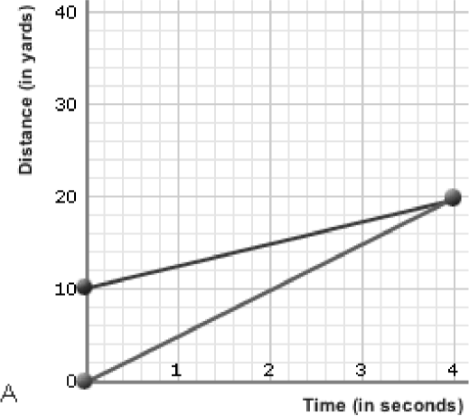
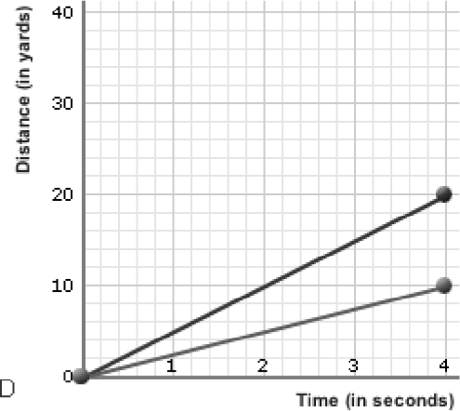
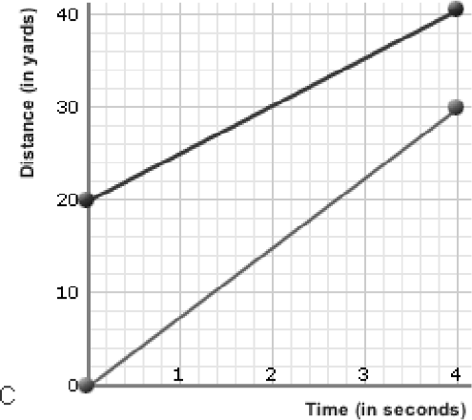
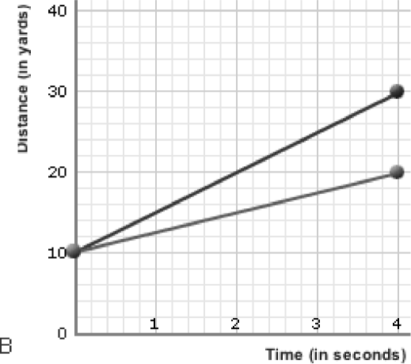
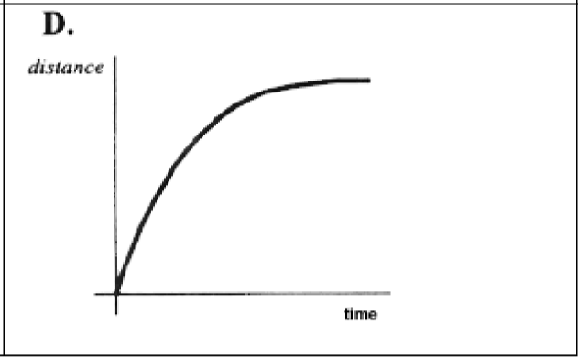
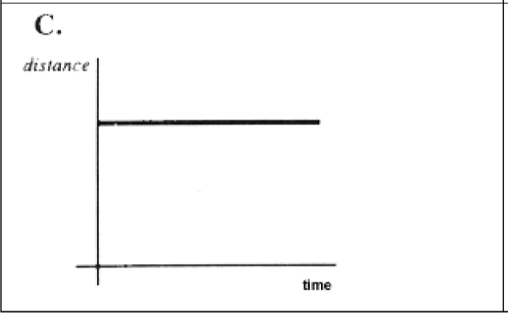
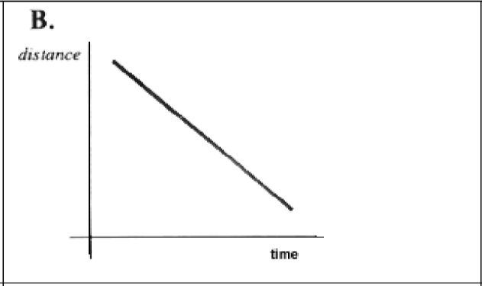
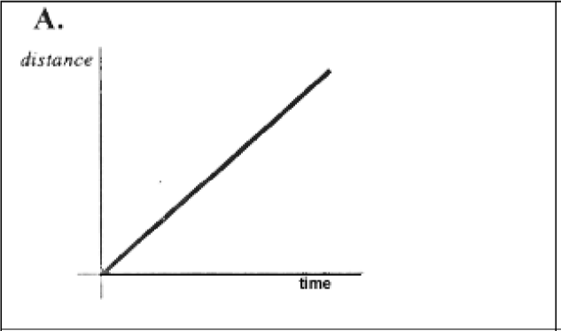

Worksheets

D-T Graphs
Total questions: 10
Name

Class

Date

- Which of the graphs shows that one of runners started 10 yards further ahead of the other?
  - b)

c) d)

- Match the description to the graph: "The car is stopped."
a) b)

c) d)

- Match the description to the graph:
"The car is traveling at a constant speed."



a) b)



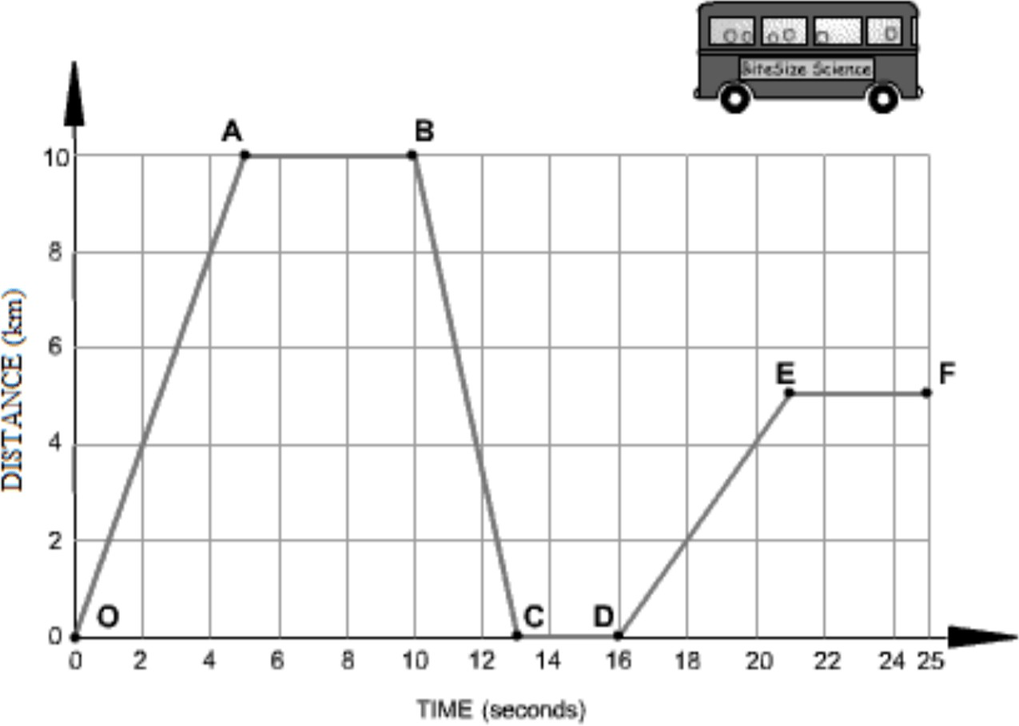
c) d)

- ​

Segment O-A The bus is .

  - returning (to original position) b) moving forward
c) at rest


- ​

Segment A-B The bus is .

  - returning (to original position) b) at rest
c) moving forward


- ​

Segment C-D The bus is .

  - at rest b) returning (to original position)
c) moving forward


- ​

Segment D-E The bus is .

  - returning (to original position) b) moving forward
c) at rest

- Which of the graphs shows that one of runners started in the same place?



a) b)



c) d)

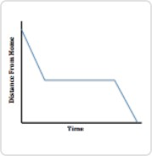
- ​

What is a plausible story for this graph?

  - A sled rider was going down a hill. The hill was steep at first, then kind of flat. At the end, it was steep again.
  - A student was jogging from school to home. She walked for a while, then continued jogging.

  - A car was slowing down, then contued moving at a constant rate. Finally, it slowed to a stop,
  - A student was jogging from school to home. She stopped to tie her shoe and take a drink from her water bottle, then continued at the same pace as before.

- 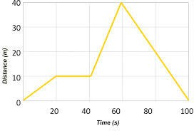

How long did it take this object to travel 10 m?

  - 15 s b) 10 s
c) 20 s d) 0 s

Answer Keys

1. | a) | 2. | b) | 3. | c)
4. | b) moving forward | 5. | b) at rest | 6. | a) at rest
7. | b) moving forward | 8. | c) , a) | 9. | d) A student was jogging
from school to home. She stopped to tie her shoe and take a drink from her water bottle, then continued at the same pace as before.

10. c) 20 s

